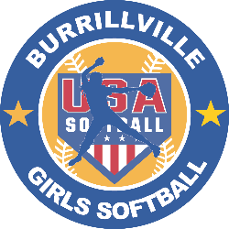
2022 Summer Sizzler Shirts
Pre Order Only
Due to supply issues, we are offering preorders only, there will be no shirts available at the tournament.
Logo on the Front, Team Names on the back.
Please email 1 Order per team no later than June 26, 2022
$20 Dollars Per Shirt 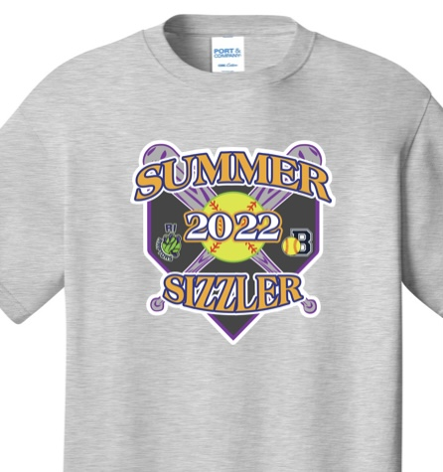

Team Name:__________________________________
Team Contact: ________________________________ Contact Cell:___________________________
Sizes:
Youth Adult:
YS:________ YM:________ YL:________ YXL:________ S: ________ M _________ LG_______

XL:________ 2XL:________

Scan / Email order to burrillvillegilrssoftball@yahoo.com

